**Work Assessment Analysis**

**Methods**

This project is going to find which place is the best place for coworking of 2022 xtern summer internship program. Since I don’t know the exact start date of this program, I suggest that the whole program will start at May 16th and will end at July 24th, the time length is 10 weeks here. Then I used google map api and folium api to get geometry information for events, restaurants, coworking places, and housing place. After figuring out all geometry information, I started clustering. I set 5 coworking places as center of each cluster. Basically, I cluster by geometry position. However, I think clustering by itself may not give me the optimal coworking place, so I not only calculate the time to the events and restaurants that for the optimal coworking place generated from clustering result, but also calculate all time spent information for other coworking place.

**Analysis**

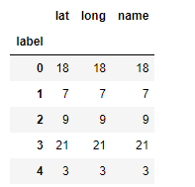In the time range from 5/16/2022 to 7/24/2022, there are 17 events nearby, including 4 conferences or TED talks. There are 35 restaurants that in the range 1000m of coworking places that have 4.5 or higher rating and can be visited as dinner place because I think for rating that is higher than4.5, food quality of restaurants will not have big difference so I can just focus on the position of restaurants. The clustering result shows that Industrious Mass Ave is the best place for coworking. It has 21 events or restaurants in the cluster. Here is the table of cluster information.

Figure 1

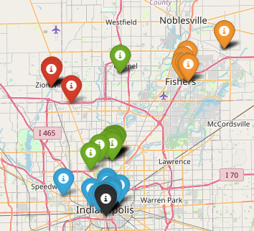And here is the clustering information on the map.

Figure 2

You can check “All_info_with_cluster.html” for a more detailed look. And “All_info_without_cluster.html” is for all information that not clustered on map.

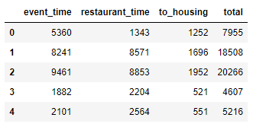Since I think clustering by itself may not give me the optimal coworking place, I scheduled events and restaurants for all coworking place to see if Industrious Mass Ave is the best place for coworking. And here is the result. I evaluate the goodness of a place by calculating the time spent on travel to there. In order to get rid of the influence of rush hour traffic, I set the departure time at 7/2/2022 23:59:59:00 for all time calculation in this project. The result still shows Industrious Mass Ave is the best coworking place overall.

Figure 3

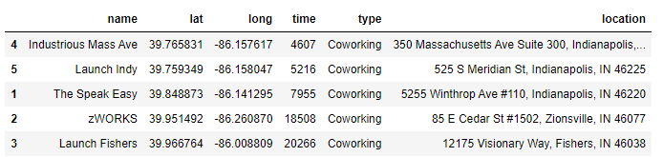I calculate event_time by adding up all time spent to events, and get restaurant_time by adding up time spent on top 10 restaurants that takes the least time to get there. to_housing is simply the time spent on traveling from coworking to housing.

Figure 4

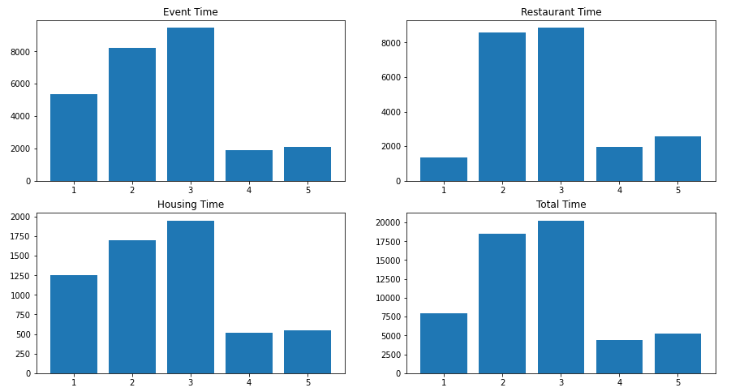We can see that Industrious Mass Ave always spent least time except on travelling to restaurants. However, the difference is not large. Therefore, based on time spent information, you always want to set coworking place at Industrious Mass Ave unless you only care about the time spent on travelling to restaurants. Here is an overall plot of all time spent.

Figure 5

There is another reason why I want to choose Industrious Mass Ave as the coworking place. It has the least time spent travel to housing. I think this is important is because that coworkers have to travel between coworking place and housing place 10 times a week. So in total there will be 100 travels between housing and coworking, and this will be a great amount of time.

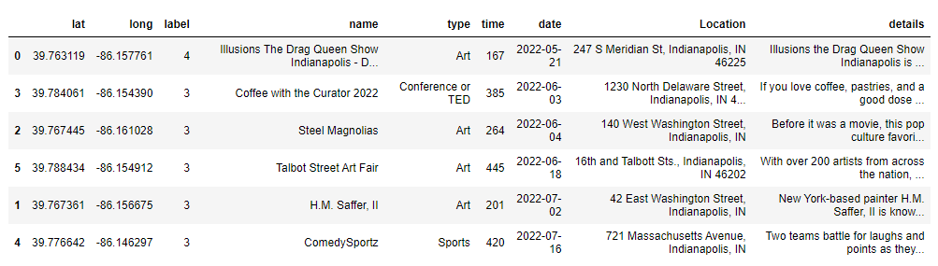The schedule I made for Industrious Mass Ave are below.

Figure 5

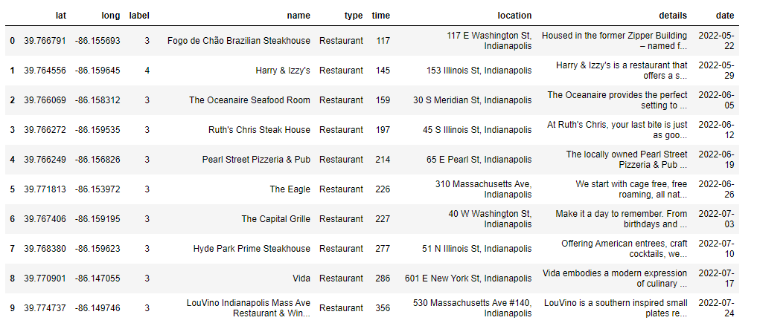

Figure 6

For a more detailed look, I stored figure 5 in “shceduled_events.csv” and figure 6 in “schedule_restaurants_info.csv”. I also attached other files. In the appendix, I will include a file description.

**Result**

From clustering alone, I suggest Industrious Mass Ave as coworking place, for time spent on travelling to scheduled events, restaurants, and housing, I would suggest Industrious Mass Ave in general. If one only care about work close to good restaurants, then I would suggest The Speak Easy, for any other condition, I would suggest Industrious Mass Ave. If one wants to spent less time one housing to coworking travelling, I would still suggest Industrious Mass Ave, for which is my biggest concern.

Appendix

**All_info_with_cluster.html**

map information of all events, restaurants, coworking, and housing, interactive, clustered

**All_info_without_cluster.html**

map information of all events, restaurants, coworking, and housing, interactive, not clustered

**Coworking_detailed_time_spent.csv**

Time spent on travelling from different coworking places to different scheduled events, restaurants, and housing. Shows total and separate data.

**Coworking_time_spent.csv**

Time spent on travelling from different coworking places to different scheduled events, restaurants, and housing. Just shows total time but includes more detailed coworking geometry information

**d.csv**

Detail information of scheduled events for Industrious Mass Ave

**d2.csv**

Detail information of scheduled restaurants for Industrious Mass Ave

**Data.csv**

Initial information of housing and coworking

**event.csv**

Nearby event information

**Housing_Coworking_Info.csv**

Coworking and housing coordinates information and time spent from coworking to housing.

**Housing_Coworking_place.html**

Map information of housing and coworking, interactive

**restaurants.csv**

All nearby restaurants. Within 1000mm, rating higher than 4.5, suitable for dinner.

**schedule_restaurants_info.csv**

Detailed information of scheduled restaurants, and the scheduled date.

**scheduled_events.csv**

Detailed information of scheduled events, and the scheduled date.

**time_spent_subplot.png**

Four plots for time spent from coworking to events, restaurants, housing, and total time spent.